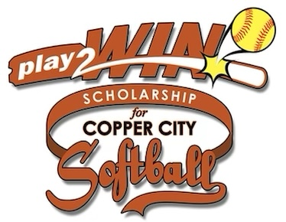

**play2WIN - Copper City Little League Softball Scholarship**

This scholarship is awarded to graduating high school Senior (s) from Butte, MT on behalf of

The Copper City Little League Softball Organization.

Scholarship Eligibility Requirements

1. Must have participated in the Copper City Little League Softball at least one year
2. Must not have any alcohol or drug convictions
3. Must have received at least two varsity letters in athletics
4. Must have a cumulative high school GPA of 3.0 or higher

Name: _______________________________________________________

Address: _____________________________________________________

School: ______________________________Phone: ­_____________________________________________

* Participation years with Copper City Softball Little League (ex 2019 to 2022). *The SANDLOT league counts towards participation*:: ____________________
* Coached by: __________________________
* Cumulative High School GPA: _______ High School Counselor Name and Phone #:___________________
* ACCOMPLISHMENTS (please list any academic and/or athletic and make sure you list your varsity letters and year and sport and at what High School):_______________________________________________________________________________________

_______________________________________________________________________________________

_______________________________________________________________________________________

_______________________________________________________________________________________

_______________________________________________________________________________________

* List any time that you volunteered for the Copper City Softball Little League:

_______________________________________________________________________________________

_______________________________________________________________________________________

* Community Involvement:

_______________________________________________________________________________________

_______________________________________________________________________________________

_______________________________________________________________________________________

_______________________________________________________________________________________

_______________________________________________________________________________________

_______________________________________________________________________________________

* College / Trade School Attending: (Note: If it’s not known, put: Undecided. _________________________

Signature of Student: _____________________________________ Date: ___________________

On a separate piece of paper, please answer the two questions below (answers should be one to two pages in length). The response to these questions will be heavily weighed when selecting awardees for this scholarship!

1. How has your participation in Copper City Softball Little League impacted you?
2. How would receiving this scholarship benefit you?

Please send completed application, copy of ALL High School transcripts, and essay responses to the following address:

**Copper City Softball Little League**

**P.O. Box 3742**

**Butte, MT 59702**

Applications must be postmarked by March 31st. Scholarship recipients will be announced May 4th, 2025 at the Copper City Softball Opening Day Ceremony.

The money will be sent directly to the Admission Office of the college / trade school that the winner has chosen to attend. In order to receive the scholarship monies, the awardee must enroll in the college/trade school of their choice within two years of being selected for the scholarship. However, if the scholarship is not used within that time period of being awarded, it will be forfeited. Award amounts and number of awardees will be determined by the number of eligible students applying. If one to five students apply, we will award one $1,500 scholarship. If more than five students apply, we will award two - $1,000 scholarships.

For questions contact Mike Bauer – 406-490-7491

Past Winners – 2024 – Ashby Lee